**DAILY ONLINE ACTIVITIES SUMMARY**

|  |  |  |  |  |  |  |  |  |
| --- | --- | --- | --- | --- | --- | --- | --- | --- |
| **Date:** | **06/07/2020** | | | | | **Name:** | **NIKHIL KUMAR** | |
| **Sem & Sec** | **4thSEM. & ‘B’ SEC.** | | | | | **USN:** | **4AL19CS400** | |
| **Online Test Summary** | | | | | | | | |
| **Subject** | | **MATHEMATICS 4** | | | | | | |
| **Max. Marks** | |  | | **Score** | | |  | |
| **Certification Course Summary** | | | | | | | | |
| **Course** | **Built your own chatbot** | | | | | | | |
| **Certificate Provider** | | | **Cognitiveclass** | | **Duration** | | | **1 week** |
| **Coding Challenges** | | | | | | | | |
| **Problem Statement1:---** Write a Java program to find the Nth natural number with exactly two bits set.  Given an integer N, the task is to find the Nth natural number with exactly two bits set.  Examples:  Input: N = 4 Output: 9  Input: N = 15 Output: 48  **Hint** ***Explanation: of 1st example*** Binary representation of numbers 1 -0001, 2- 0010, **3- 0011**, 4-0100, **5-0101**, **6-0110**, 7- 0111, 8-1000, **9 - 1001**, **10- 1010** etc. Here only for the bold numbers binary values contains exactly 2 bits 1's hence Numbers with exactly two bits set: 3, 5, 6, 9, 10, 12, … 4th number in this is 9.  **Therefore output is 9** | | | | | | | | |
| **Status: ---executed** | | | | | | | | |
| **Uploaded the report in Github** | | | | | **Yes** | | | |
| **If yes Repository name** | | | | | <https://github.com/Nikhil401/java-coding/blob/master/Nth.java> | | | |
| **Uploaded the report in slack** | | | | | **Yes** | | | |

**Online Test Summary : Subject 18MAT41 IA test Descriptive was conducted from module:1 there were 3 question and time assigned from 09:30 to 10:15**

**Certification Course Summary: Today I have finished the certification course “Built your own chat-bot”.**

**Snapshot is given below** 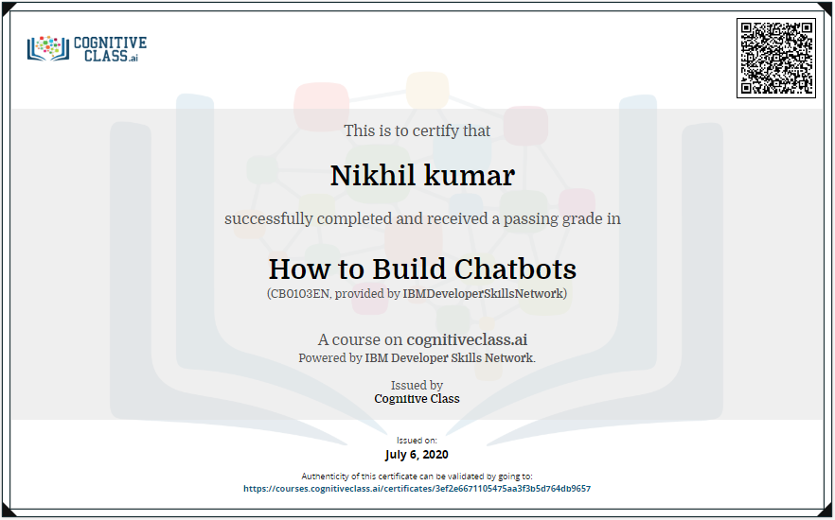

**Online coding summary: Today I had received programs which is mentioned in table above and I have uploaded into the github repository. Snapshot of the program is given below:**

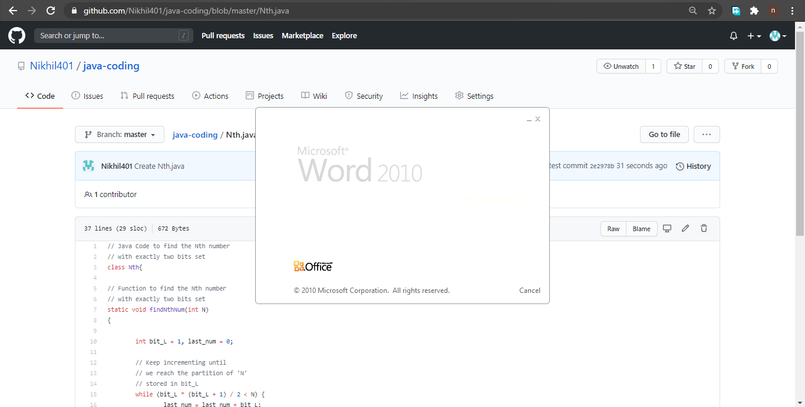

**Thank you.**